SKÖNDALSVILLAN, plan 2 & 4, 8/4 – 14/4 v.15

|  |  |  |  |  |  |  |
| --- | --- | --- | --- | --- | --- | --- |
| MÅNDAG  8/4 | TISDAG  9/4 | ONSDAG  10/4 | TORSDAG  11/4 | FREDAG  12/4 | LÖRDAG  13/4 | SÖNDAG  14/4 |
| **TV: 10.00, svt1 Hemmagympa med Sofia  13.30**  **Promenadgrupp** - boende tillsammans med personal och Tyresö Väntjänst. **Samling vid entrén**  **14.30**  [Tillväxt Lidköping bjuder in till after work med musikquiz hos O ...](https://www.google.se/imgres?imgurl=https://tillvaxtlidkoping.se/wp-content/uploads/2017/05/music-1428660_1920-776x415.jpg&imgrefurl=https://tillvaxtlidkoping.se/2017/05/08/tillvaxt-lidkoping-bjuder-in-till-after-work-med-musikquiz-hos-olearys-lidkoping/&tbnid=JNX31zHMosRBCM&vet=10CBYQMyhyahcKEwjw7KuN5bPrAhUAAAAAHQAAAAAQAg..i&docid=MT_c5YVL12O-8M&w=776&h=415&q=musikquiz&hl=sv&ved=0CBYQMyhyahcKEwjw7KuN5bPrAhUAAAAAHQAAAAAQAg)**Musik med Gunilla plan 4**  **TV: 17.30, svt1 Sverige idag**  **En bild som visar Människoansikte, person, klädsel, text  Automatiskt genererad beskrivning** | **TV: 10.00, svt1 Hemmagympa med Sofia** PROMENADER ELLER UTEVISTELSE – Planera tillsammans med din omsorgssamordnare  **14.15, plan 5**  **Sittgympa med Roger, på TV:n (fysioterapeut som filmat sin instruktion) En bild som visar person, vägg, Fysisk kondition, klädsel  Automatiskt genererad beskrivning**  **15-17, plan 5 ’Öppet hus’ på terrassen – fixande inför odlingssäsongen**  **TV: 18.45, svt1 Go’kväll**  **En bild som visar Människoansikte, klädsel, himmel, person  Automatiskt genererad beskrivning** | **11.00**  [Tillväxt Lidköping bjuder in till after work med musikquiz hos O ...](https://www.google.se/imgres?imgurl=https://tillvaxtlidkoping.se/wp-content/uploads/2017/05/music-1428660_1920-776x415.jpg&imgrefurl=https://tillvaxtlidkoping.se/2017/05/08/tillvaxt-lidkoping-bjuder-in-till-after-work-med-musikquiz-hos-olearys-lidkoping/&tbnid=JNX31zHMosRBCM&vet=10CBYQMyhyahcKEwjw7KuN5bPrAhUAAAAAHQAAAAAQAg..i&docid=MT_c5YVL12O-8M&w=776&h=415&q=musikquiz&hl=sv&ved=0CBYQMyhyahcKEwjw7KuN5bPrAhUAAAAAHQAAAAAQAg)**Musik med Gunilla pl 2**  PROMENADER ELLER UTEVISTELSE – Planera tillsammans med din omsorgssamordnare  **16.00, plan 5  Högläsning Anmäl intresse till Gunilla**  **TV: 18.45, svt1 Go’kväll**  **En bild som visar Människoansikte, klädsel, himmel, person  Automatiskt genererad beskrivning** |  | **TV: 10.00, svt1 Hemmagympa med Sofia**  **14.00, plan 3 14.30, plan 2 Pianokonsert Kent Sjöberg**   | **TV: 13.20, svt1 Sverige!** | **TV: 10.00, svt2 Gudstjänst från Smyrna Frihamnskyrkan** **TV: 18.15, svt1 Landet runt** |

[](https://se.freeimages.com/premium/retro-cartoon-coffee-mug-573966)[](https://www.google.se/imgres?imgurl=https://energydrink.redbull.com/sites/default/files/image-server/ingredients/caffeine/global/FMR-RedBull_Icon_InstantCoffee_1-min.jpg&imgrefurl=https://energydrink-sa.redbull.com/en/red-bull-caffeine-content&docid=-rFWiobZ0kX5pM&tbnid=9iOHWq60brOwfM:&vet=12ahUKEwj33YKL9svmAhWBxMQBHSwxAb84ZBAzKCUwJXoECAEQLg..i&w=406&h=392&bih=962&biw=1920&q=kaffekopp%20tecknad&ved=2ahUKEwj33YKL9svmAhWBxMQBHSwxAb84ZBAzKCUwJXoECAEQLg&iact=mrc&uact=8)[](https://www.google.se/imgres?imgurl=https://png.clipart.me/istock/previews/3976/39761196-funny-vintage-cartoon-waiter-with-cup-of-coffee.jpg&imgrefurl=https://se.clipart.me/istock/funny-vintage-cartoon-waiter-with-cup-of-coffee-86121&tbnid=G5f_sWL8ELCXaM&vet=10CBUQMyhuahcKEwiAh9rVzqjnAhUAAAAAHQAAAAAQDg..i&docid=LHqbpCf5YxLyNM&w=172&h=199&q=caf%C3%A9%20tecknat&ved=0CBUQMyhuahcKEwiAh9rVzqjnAhUAAAAAHQAAAAAQDg)[](https://www.google.se/imgres?imgurl=http://robbansbasta.se/wp-content/uploads/2015/07/fika-logo-1.jpg&imgrefurl=http://robbansbasta.se/tips-pa-nya-fikastallen/&tbnid=TxUfBcGui-EbXM&vet=10CJMBEDMorAFqFwoTCICH2tXOqOcCFQAAAAAdAAAAABAO..i&docid=PgK52-bHU7QzqM&w=842&h=567&q=caf%C3%A9%20tecknat&ved=0CJMBEDMorAFqFwoTCICH2tXOqOcCFQAAAAAdAAAAABAO)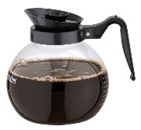[](https://www.google.se/imgres?imgurl=https://www.fungadgets.se/wp-content/uploads/2014/03/Kaffe-Stenciler1-600x585.png&imgrefurl=https://www.fungadgets.se/p/kaffe-stenciler/&tbnid=-AkLLR8uwzEuOM&vet=10CAcQMygDahcKEwiAjJmouaTpAhUAAAAAHQAAAAAQBQ..i&docid=Y7R51Ta98jjf5M&w=600&h=585&q=kaffe&ved=0CAcQMygDahcKEwiAjJmouaTpAhUAAAAAHQAAAAAQBQ)[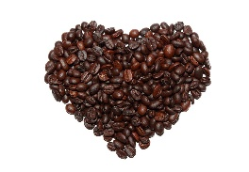](https://www.google.se/url?sa=i&url=https://iform.se/nyttig-mat/traningskost/kost-som-okar-prestationsformagan-kaffe-gor-dig-uthalligare&psig=AOvVaw2wxiEbXZoU4tB1IPFxJEyq&ust=1589033520432000&source=images&cd=vfe&ved=0CAIQjRxqFwoTCICMmai5pOkCFQAAAAAdAAAAABAI)

[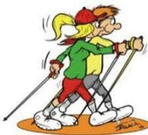](https://www.google.se/url?sa=i&url=https://www.spfseniorerna.se/distrikt/sodra-alvsborgsdistriktet/foreningslista/spf-seniorerna-svenljunga/aktiviteter/promenader/&psig=AOvVaw1RwGB_MisUCmraiGU5UGM_&ust=1617978384124000&source=images&cd=vfe&ved=0CAIQjRxqFwoTCPDH67ft7u8CFQAAAAAdAAAAABAJ)[](https://www.google.se/imgres?imgurl=https://josefinlchf.files.wordpress.com/2012/03/powerwalk_127637536_191082444.jpg?w%3D640&imgrefurl=https://josefinlchf.wordpress.com/2012/03/07/powerwalks/&tbnid=mfMrkENkglByVM&vet=10CBEQxiAoB2oXChMIqOm16Jb47wIVAAAAAB0AAAAAEAc..i&docid=N18xXo8k9dJ99M&w=271&h=373&itg=1&q=promenad&ved=0CBEQxiAoB2oXChMIqOm16Jb47wIVAAAAAB0AAAAAEAc)[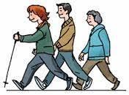](https://www.google.se/imgres?imgurl=https://pro.se/images/18.42708e36174e43619e96893/1601756824201/Promenad,1%5b1%5d.jpg&imgrefurl=https://pro.se/distrikt/distrikt-medelpad/samorganisationer/samorganisation-sundsvall/foreningar/city-sundsvall/aktiviteter/promenader.html&tbnid=-UgWwZI5ev4GTM&vet=10CBUQxiAoA2oXChMIqOm16Jb47wIVAAAAAB0AAAAAEAc..i&docid=xiXiIbO2iO4eXM&w=176&h=130&itg=1&q=promenad&ved=0CBUQxiAoA2oXChMIqOm16Jb47wIVAAAAAB0AAAAAEAc)[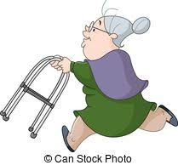](https://www.google.se/imgres?imgurl=https://cdn.xl.thumbs.canstockphoto.se/fotg%C3%A4ngare-spring-kvinna-gammal-clipart-vektor_csp24245352.jpg&imgrefurl=https://www.canstockphoto.se/gammal-spring-vektor-dam-tecknad-58751859.html&tbnid=zGa0vN0PoGQEsM&vet=10CGwQMyiZAWoXChMIgNClxoKn6gIVAAAAAB0AAAAAEAI..i&docid=--J7dtuUtAbuBM&w=209&h=194&q=tr%C3%A4ningsoverall%20%C3%A4ldre%20clip%20art&hl=sv&ved=0CGwQMyiZAWoXChMIgNClxoKn6gIVAAAAAB0AAAAAEAI)[](https://www.google.se/imgres?imgurl=http://2.bp.blogspot.com/_Fuob9trC41M/S-bnm3mefeI/AAAAAAAABeY/6l9rG1u2yXU/s1600/nillan_rullator_2004.gif&imgrefurl=http://undrarsa.blogspot.com/2010/05/&tbnid=4zVPh9hCpD_RzM&vet=10CCwQMygSahcKEwiQ9KKu_qbqAhUAAAAAHQAAAAAQCg..i&docid=zLvu_7YsZZLw-M&w=194&h=383&q=promenad%20tecknad%20bild&hl=sv&ved=0CCwQMygSahcKEwiQ9KKu_qbqAhUAAAAAHQAAAAAQCg)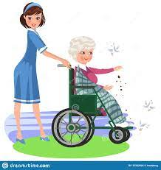[](https://www.google.se/imgres?imgurl=https://thumbs.dreamstime.com/z/tecknad-filmpojke-med-mormodern-i-rullstol-92627510.jpg&imgrefurl=https://se.dreamstime.com/stock-illustrationer-tecknad-filmpojke-med-mormodern-i-rullstol-image92627510&tbnid=ZavkAB165fR4JM&vet=12ahUKEwihou2MuvjvAhXeBXcKHSqkDNkQMyghegUIARC7Ag..i&docid=57OJZ1l2y-L9QM&w=1278&h=1300&q=rullstol%20tecknat&hl=sv&ved=2ahUKEwihou2MuvjvAhXeBXcKHSqkDNkQMyghegUIARC7Ag)[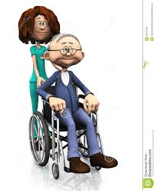](https://www.google.se/imgres?imgurl=https://thumbs.dreamstime.com/z/f%C3%B6r-mansjuksk%C3%B6terska-f%C3%B6r-tecknad-film-hj%C3%A4lpande-%C3%A4ldre-rullstol-23272703.jpg&imgrefurl=https://se.dreamstime.com/arkivfoton-f%C3%B6r-mansjuksk%C3%B6terska-f%C3%B6r-tecknad-film-hj%C3%A4lpande-%C3%A4ldre-rullstol-image23272703&tbnid=NgnVMswjHlkwQM&vet=12ahUKEwihou2MuvjvAhXeBXcKHSqkDNkQMygsegUIARDVAg..i&docid=1LwTTHZzdDrEuM&w=1065&h=1300&q=rullstol%20tecknat&hl=sv&ved=2ahUKEwihou2MuvjvAhXeBXcKHSqkDNkQMygsegUIARDVAg)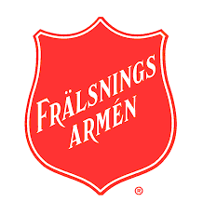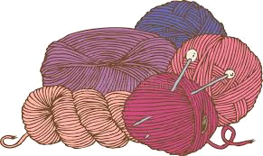[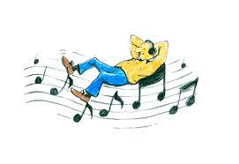](https://www.google.se/imgres?imgurl=http://ingerkruchov.dk/wp-content/uploads/2015/02/Musikterapi-2.png&imgrefurl=http://ingerkruchov.dk/behandling-5/gim-musikterapi-2/&tbnid=bwXnLjnfJJyUaM&vet=10CEIQMyiDAWoXChMIqILJzpf47wIVAAAAAB0AAAAAEAI..i&docid=VaXRs5N0Zp9w_M&w=271&h=186&q=musikterapi&ved=0CEIQMyiDAWoXChMIqILJzpf47wIVAAAAAB0AAAAAEAI)[](https://www.google.se/imgres?imgurl=https://gbgq.se/quiz/wp-content/uploads/gbgq-musik.png&imgrefurl=https://gbgq.se/quiz/&tbnid=2R-Ez4c5FMzPJM&vet=10CF0QMyiUAWoXChMI8OyrjeWz6wIVAAAAAB0AAAAAEAI..i&docid=CiCD8NuTzCSfZM&w=700&h=362&q=musikquiz&hl=sv&ved=0CF0QMyiUAWoXChMI8OyrjeWz6wIVAAAAAB0AAAAAEAI) 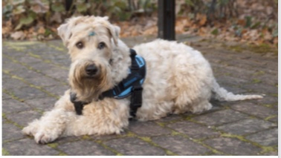[](https://www.google.se/imgres?imgurl=http://h%C3%A4lsap%C3%A5.com/wp-content/uploads/2019/09/sittgympa-edit.png&imgrefurl=http://xn--hlsap-gral.com/sittgymnastik/&tbnid=SDb0ATPKjCQC2M&vet=12ahUKEwiZyMDT7q3nAhWPBncKHUJEDr8QMygcegQIARBC..i&docid=gFq1nDSzamRqEM&w=850&h=495&q=sittgympa&ved=2ahUKEwiZyMDT7q3nAhWPBncKHUJEDr8QMygcegQIARBC)[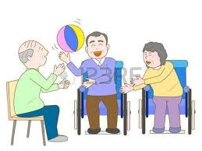](https://www.google.se/imgres?imgurl=https://lookaside.fbsbx.com/lookaside/crawler/media/?media_id%3D1031800540329758&imgrefurl=https://www.facebook.com/588219181354565/posts/sittgympa-idag/1031800566996422/&tbnid=W8XoS4Af9hXEhM&vet=12ahUKEwiZyMDT7q3nAhWPBncKHUJEDr8QMyg2egQIARB5..i&docid=zJdTSOTFB8591M&w=450&h=338&q=sittgympa&ved=2ahUKEwiZyMDT7q3nAhWPBncKHUJEDr8QMyg2egQIARB5) 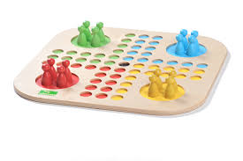[](https://www.google.se/imgres?imgurl=https://tillvaxtlidkoping.se/wp-content/uploads/2017/05/music-1428660_1920-776x415.jpg&imgrefurl=https://tillvaxtlidkoping.se/2017/05/08/tillvaxt-lidkoping-bjuder-in-till-after-work-med-musikquiz-hos-olearys-lidkoping/&tbnid=JNX31zHMosRBCM&vet=10CBYQMyhyahcKEwjw7KuN5bPrAhUAAAAAHQAAAAAQAg..i&docid=MT_c5YVL12O-8M&w=776&h=415&q=musikquiz&hl=sv&ved=0CBYQMyhyahcKEwjw7KuN5bPrAhUAAAAAHQAAAAAQAg)[](https://www.google.se/imgres?imgurl=https://www.bakemyday.se/wp-content/uploads/2018/10/2700_2701_2702.png&imgrefurl=https://www.bakemyday.se/product/prinsesstarta-gron-8-bitar/&docid=0emiJO3v8kNtYM&tbnid=W0Xj9U-dIIvWpM:&vet=1&w=2070&h=1277&bih=962&biw=1920&ved=2ahUKEwinuJOb-MvmAhWMyqYKHclMAkkQxiAoBXoECAEQHg&iact=c&ictx=1)[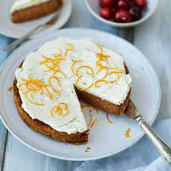](https://www.google.se/imgres?imgurl=https://mittkok.expressen.se/wp-content/uploads/2018/10/morotskaka-700x700.jpg&imgrefurl=https://mittkok.expressen.se/recept/morotskaka-10/&tbnid=LnnAiMvJveyZ1M&vet=10CAMQxiAoAGoXChMIgO6o7_qo5wIVAAAAAB0AAAAAEAc..i&docid=jOg5KhmD4MxNjM&w=700&h=700&itg=1&q=morotskaka&ved=0CAMQxiAoAGoXChMIgO6o7_qo5wIVAAAAAB0AAAAAEAc) [](https://www.google.se/url?sa=i&url=https://www.spfseniorerna.se/distrikt/Kronobergsdistriktet/foreningslista/spf-seniorerna-berga/nyheter/2019/december/bowling/&psig=AOvVaw0v0PLnkUfReIEjy6GEzzRE&ust=1579361886052000&source=images&cd=vfe&ved=0CAIQjRxqFwoTCMD2l-L7iucCFQAAAAAdAAAAABAD)[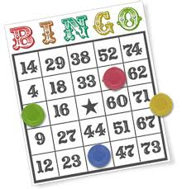](https://www.google.se/imgres?imgurl=https://cdn.shortpixel.ai/client/q_glossy,ret_img/https://www.hajper.com/go/wp-content/uploads/2019/11/bingo_side.png&imgrefurl=https://www.hajper.com/go/bingo/&tbnid=nXUwb8jvoSHF1M&vet=12ahUKEwi52ZOVjM7nAhWXwSoKHdfjD90QMyghegQIARBH..i&docid=jL8gMZCp7tbT8M&w=540&h=560&q=bingo&ved=2ahUKEwi52ZOVjM7nAhWXwSoKHdfjD90QMyghegQIARBH) [](https://www.google.se/imgres?imgurl=https://static.vecteezy.com/system/resources/previews/000/494/490/non_2x/palette-for-paints-and-brush-vector-illustration.jpg&imgrefurl=https://sv.vecteezy.com/vektor-konst/494490-palett-for-malar-och-borste-vektor-illustration&tbnid=mnx10tCvoHCecM&vet=10CDQQMyh3ahcKEwjQ3Jjc2pfoAhUAAAAAHQAAAAAQBA..i&docid=Tc1Fbieqge6v5M&w=381&h=490&q=palett&ved=0CDQQMyh3ahcKEwjQ3Jjc2pfoAhUAAAAAHQAAAAAQBA) 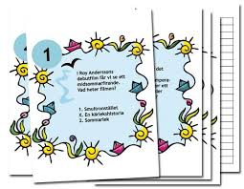 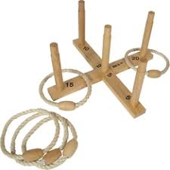 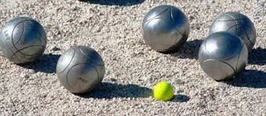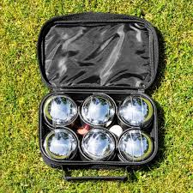[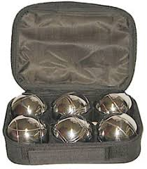](https://www.google.se/imgres?imgurl=https://www.hjalpmedel.com/images/normal/boule-ute.jpg&imgrefurl=https://www.hjalpmedel.com/spel-fritid/boccia/boule-ute/&tbnid=aPP7V1K9PT39JM&vet=12ahUKEwiA36_b7sfrAhWNzaYKHaXyA0kQMygaegUIARDvAg..i&docid=sZbst3GXcjxfiM&w=237&h=270&q=boule&ved=2ahUKEwiA36_b7sfrAhWNzaYKHaXyA0kQMygaegUIARDvAg)[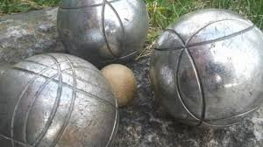](https://www.google.se/imgres?imgurl=https://www.visitdalarna.se/sites/cb_dalarna/files/styles/slide_large/http/images.citybreak.com/3153357.jpeg?itok%3DmPpqZcgX&imgrefurl=https://www.visitdalarna.se/boule-klotskallehallen&tbnid=6qYNHRJEQyy30M&vet=12ahUKEwiA36_b7sfrAhWNzaYKHaXyA0kQMyhOegUIARDvAQ..i&docid=XQNahQ__m3mSAM&w=1440&h=810&q=boule&ved=2ahUKEwiA36_b7sfrAhWNzaYKHaXyA0kQMyhOegUIARDvAQ)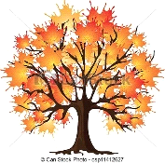 [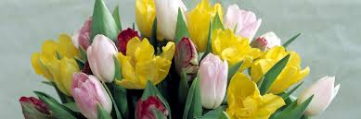](https://www.google.se/imgres?imgurl=http://sorby.com/News/Image/2039/07.jpg?ts%3D637195240114900000&imgrefurl=http://sorby.com/&tbnid=K0kzscknlVFFjM&vet=10CEQQMyjoAWoXChMIgLCyn7jM6AIVAAAAAB0AAAAAEAU..i&docid=bMhYB6EbfuTqMM&w=1140&h=380&itg=1&q=p%C3%A5skblommor&ved=0CEQQMyjoAWoXChMIgLCyn7jM6AIVAAAAAB0AAAAAEAU)[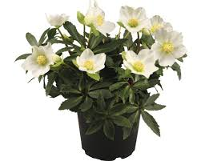](https://www.google.se/imgres?imgurl=https://cdn.hornbach.se/data/shop/D04/001/780/491/369/318/DV_8_6726874_01_4c_DE_20180528182604.jpg&imgrefurl=https://www.hornbach.se/shop/Julros-FLORASELF-Helleborus-niger-Little-Darling-13cm/6726874/artikel-detaljer.html&tbnid=1pHXaon4RO7N7M&vet=10CIsBEDMo8gJqFwoTCKCx3o2qou0CFQAAAAAdAAAAABAH..i&docid=gULEDVEj7Tv4VM&w=500&h=400&q=julros&ved=0CIsBEDMo8gJqFwoTCKCx3o2qou0CFQAAAAAdAAAAABAH)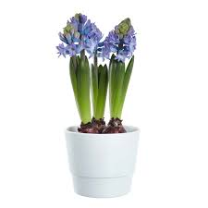[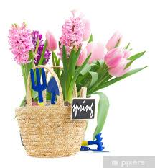](https://www.google.se/imgres?imgurl=https://img.pixers.pics/pho_wat(s3:700/FO/62/12/25/47/700_FO62122547_c046882e1f398601355f611e6b66e9ae.jpg,650,700,cms:2018/10/5bd1b6b8d04b8_220x50-watermark.png,over,430,650,jpg)/fototapeter-tradgardsredskap-med-rosa-hyacint-och-tulpan.jpg.jpg&imgrefurl=https://pixers.se/fototapeter/tradgardsredskap-med-rosa-hyacint-och-tulpan-62122547&tbnid=iWpzrw4DHYjoTM&vet=12ahUKEwiv89C4jqXuAhVJgosKHX8GCY8QMygqegUIARDZAg..i&docid=GhVTL8KQ5RRvvM&w=650&h=700&itg=1&q=rosa%20hyacint&ved=2ahUKEwiv89C4jqXuAhVJgosKHX8GCY8QMygqegUIARDZAg)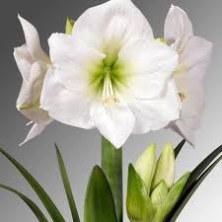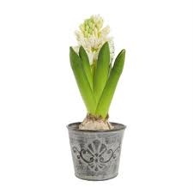[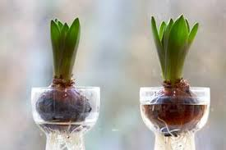](https://www.google.se/imgres?imgurl=https://cached-images.bonnier.news/bnl01/standard-article/35d278c1-a7cc-4760-bcbe-2cfe91d7efb4/66c568b6-0543-4a17-8e95-bfacadd2e0dd/annan/0/320@80.jpg&imgrefurl=https://www.expressen.se/amelia/livsstil/sa-tar-du-hand-om-julens-mest-populara-blommor/&tbnid=YWSj7Q9wzygD0M&vet=12ahUKEwjc0qLOqaLtAhUKxioKHYsPBIkQMygUegUIARDpAg..i&docid=hOSx9Qe3zPz_WM&w=320&h=213&q=hyacint&ved=2ahUKEwjc0qLOqaLtAhUKxioKHYsPBIkQMygUegUIARDpAg)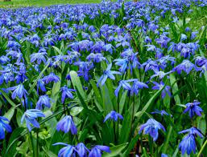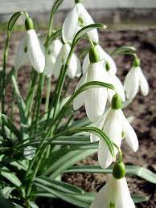[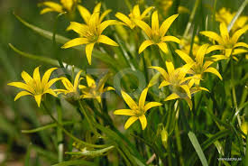](https://www.google.se/imgres?imgurl=https://d1zdvrhnnyix6g.cloudfront.net/w850/beb_BEE0032.jpg&imgrefurl=https://www.azote.se/image/tuva/V%C3%A5rl%C3%B6k,%20(Gagea%20lutes)/53846&tbnid=9mvEJXvP7qemJM&vet=10CO8BEDMomANqFwoTCPjz2rvy7u8CFQAAAAAdAAAAABAE..i&docid=46IV9lbfloQ3DM&w=850&h=569&q=v%C3%A5rl%C3%B6k&ved=0CO8BEDMomANqFwoTCPjz2rvy7u8CFQAAAAAdAAAAABAE)[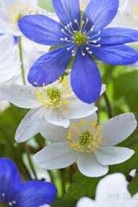](https://www.google.se/imgres?imgurl=http://static.beta.pixgallery.com/images/detail/I/7/H/PIX-I7HTNV.jpg&imgrefurl=http://www.pixgallery.com/i/I7HTNV&tbnid=ztmbfWdttwCEyM&vet=12ahUKEwju2Y278O7vAhUIyyoKHcspD7IQMyhJegQIARBz..i&docid=ZdOz_qL7kPflIM&w=300&h=450&q=v%C3%A5rblommor&ved=2ahUKEwju2Y278O7vAhUIyyoKHcspD7IQMyhJegQIARBz)[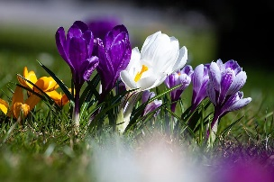](https://www.google.se/url?sa=i&url=https://hemmanytt.se/tradgard/varblommor-lista/&psig=AOvVaw26YoqnNmdD0HbQwFUQNpvd&ust=1617979229523000&source=images&cd=vfe&ved=0CAIQjRxqFwoTCKCHudLw7u8CFQAAAAAdAAAAABAE)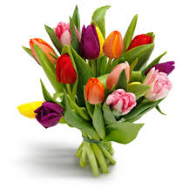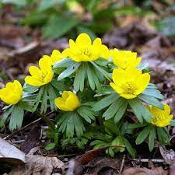 [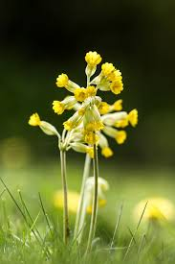](https://www.google.se/imgres?imgurl=https://www.fotosidan.se/cldocpart/580697.jpg&imgrefurl=https://www.fotosidan.se/blogs/stefan-arvidsson/varblommor-i-tradgarden.htm&tbnid=v0DZHMe-TH_snM&vet=12ahUKEwixwqn90bfwAhWMw4sKHZ8TDrEQMygVegUIARCHAg..i&docid=qiq1QBL9tAS4kM&w=1080&h=1620&q=v%C3%A5rblommor&ved=2ahUKEwixwqn90bfwAhWMw4sKHZ8TDrEQMygVegUIARCHAg) [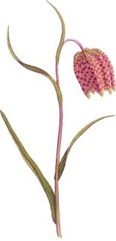](https://www.google.se/imgres?imgurl=https://www.larssons-begravningsbyra.se/sites/default/files/symbols/12124_kungsangslilja.png&imgrefurl=https://www.larssons-begravningsbyra.se/kungs%C3%A4ngslilja-2&tbnid=-iNG6butcLN21M&vet=10CM0BEDMovgFqFwoTCMjCtdTTt_ACFQAAAAAdAAAAABAC..i&docid=EZlzCPREu-AsNM&w=227&h=472&q=kungs%C3%A4ngslilja&ved=0CM0BEDMovgFqFwoTCMjCtdTTt_ACFQAAAAAdAAAAABAC) [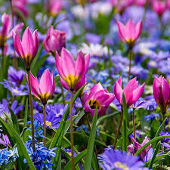](https://www.google.se/imgres?imgurl=https://i.pinimg.com/originals/3e/7e/86/3e7e86a46d784538dc4a4f11d6ca0a4b.jpg&imgrefurl=https://www.pinterest.se/pin/511862313895227845/&tbnid=WxX74puZ_w3FYM&vet=12ahUKEwixwqn90bfwAhWMw4sKHZ8TDrEQMyhGegUIARCKAQ..i&docid=4CliEzsCng8mNM&w=800&h=800&q=v%C3%A5rblommor&ved=2ahUKEwixwqn90bfwAhWMw4sKHZ8TDrEQMyhGegUIARCKAQ) [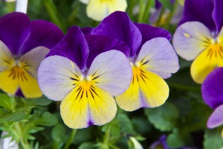](https://www.google.se/url?sa=i&url=https://www.blomsterlandet.se/tips-rad/tradgard/sommarblommor/pense-en-frosttalig-varblomma/&psig=AOvVaw1Ed9NttZopGhknmchSz1Vu&ust=1620479307791000&source=images&cd=vfe&ved=0CAIQjRxqFwoTCLCx8oDSt_ACFQAAAAAdAAAAABAF) En bild som visar full av färg, olika, växt, ordnad
**[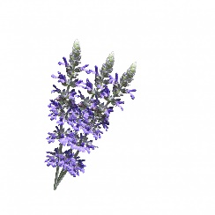](https://www.google.se/url?sa=i&url=https://www.publicdomainpictures.net/se/view-image.php?image%3D246338%26picture%3Dlavendel-blommor-vit-bakgrund&psig=AOvVaw1iYffm2LoOtgvgxNjOmmoC&ust=1593242190899000&source=images&cd=vfe&ved=0CAIQjRxqFwoTCNCNosf4nuoCFQAAAAAdAAAAABAE)[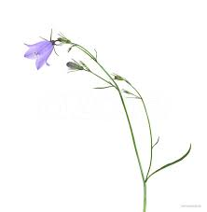](https://www.google.se/imgres?imgurl=https://d1zdvrhnnyix6g.cloudfront.net/w850/hlb_ol1297.jpg&imgrefurl=https://www.azote.se/image/%C3%84ngsklocka-Campanula-rotundifolia-isolerad-mot-vit-bakgrund/bakgrund/75522/72&tbnid=nBwTFNsq6Vi8eM&vet=12ahUKEwiBmvTn957qAhXOuCoKHXupDs4QMyhbegUIARDBAQ..i&docid=bWTMR7srLEs3QM&w=830&h=850&itg=1&q=blomma%20vit%20bakgrund&hl=sv&ved=2ahUKEwiBmvTn957qAhXOuCoKHXupDs4QMyhbegUIARDBAQ)[](https://www.google.se/imgres?imgurl=https://static.vecteezy.com/system/resources/previews/000/410/545/non_2x/vector-illustration-of-forget-me-not-flower-isolated-on-white-background.jpg&imgrefurl=https://sv.vecteezy.com/vektor-konst/410545-illustration-av-glom-mig-inte-blomma-isolerad-pa-vit-bakgrund&tbnid=kW6pH0M29aKP5M&vet=12ahUKEwiBmvTn957qAhXOuCoKHXupDs4QMyhfegUIARDKAQ..i&docid=NVI6jfsBJHfRqM&w=490&h=490&q=blomma%20vit%20bakgrund&hl=sv&ved=2ahUKEwiBmvTn957qAhXOuCoKHXupDs4QMyhfegUIARDKAQ)[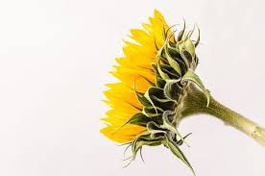](https://www.google.se/imgres?imgurl=https://p2.piqsels.com/preview/244/420/52/bloom-blossom-bouquet-color-thumbnail.jpg&imgrefurl=https://www.piqsels.com/sv/search?q%3Disolerad%2Bp%C3%A5%2Bvit%2Bbakgrund%26page%3D23&tbnid=6Xdryl6PPrLjgM&vet=12ahUKEwiBmvTn957qAhXOuCoKHXupDs4QMyhaegUIARC_AQ..i&docid=2OcVu5OE4Ey_lM&w=483&h=320&itg=1&q=blomma%20vit%20bakgrund&hl=sv&ved=2ahUKEwiBmvTn957qAhXOuCoKHXupDs4QMyhaegUIARC_AQ)[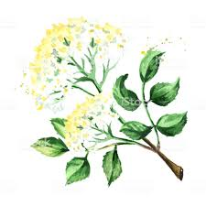](https://www.google.se/imgres?imgurl=https://media.istockphoto.com/illustrations/elder-flower-blossoms-watercolor-hand-drawn-illustration-isolated-on-illustration-id1051781444&imgrefurl=https://www.istockphoto.com/se/vektor/fl%C3%A4derblom-blommar-akvarell-handritad-illustration-isolerad-p%C3%A5-vit-bakgrund-gm1051781444-281211084&tbnid=6_5Z8fMN0H6QfM&vet=10CKwBEDMorgFqFwoTCNCNosf4nuoCFQAAAAAdAAAAABAC..i&docid=y9p1dJu0uume8M&w=1024&h=1024&q=blomma%20vit%20bakgrund&hl=sv&ved=0CKwBEDMorgFqFwoTCNCNosf4nuoCFQAAAAAdAAAAABAC)[](https://www.google.se/imgres?imgurl=https://s1.1zoom.me/big0/511/Roses_Pink_color_White_background_539141_1280x853.jpg&imgrefurl=https://www.1zoom.me/sv/wallpaper/539141/z2051.2/&tbnid=Wbw-YM74qHoAXM&vet=10CFUQMyglahcKEwjQjaLH-J7qAhUAAAAAHQAAAAAQCQ..i&docid=6pWg7RSs8wOs1M&w=1280&h=853&itg=1&q=blomma%20vit%20bakgrund&hl=sv&ved=0CFUQMyglahcKEwjQjaLH-J7qAhUAAAAAHQAAAAAQCQ)[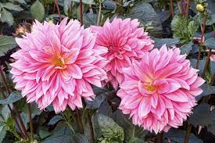](https://www.google.se/imgres?imgurl=https://get.pxhere.com/photo/plant-flower-petal-autumn-botany-flowers-dahlia-dahlias-floristry-autumn-flowers-flowering-plant-daisy-family-asterales-annual-plant-land-plant-hedgehog-cactus-autumn-dahlias-1363624.jpg&imgrefurl=https://pxhere.com/sv/photo/1363624&tbnid=ZTGt4zVI0vQubM&vet=12ahUKEwirmJzm1dDyAhVHySoKHUnBCSIQMygregUIARDYAg..i&docid=SVroAiEM5G1lOM&w=4272&h=2848&q=h%C3%B6stblommor&ved=2ahUKEwirmJzm1dDyAhVHySoKHUnBCSIQMygregUIARDYAg)[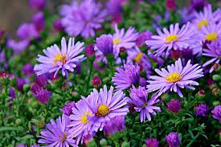](https://www.google.se/imgres?imgurl=https://cdn.pixabay.com/photo/2017/09/21/19/56/herbstastern-2773261_960_720.jpg&imgrefurl=https://pixabay.com/fi/photos/herbstastern-asteri-syksy-kukat-2773261/&tbnid=u_raN1s6nxmk7M&vet=10CBcQxiAoB2oXChMIyJPn69XQ8gIVAAAAAB0AAAAAEA0..i&docid=btHlPVAVXdOHKM&w=960&h=640&itg=1&q=h%C3%B6stblommor&ved=0CBcQxiAoB2oXChMIyJPn69XQ8gIVAAAAAB0AAAAAEA0)[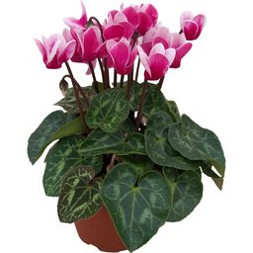](https://www.google.se/url?sa=i&url=https://www.plantagen.se/hostblommor/&psig=AOvVaw1b7ry427w8-NIXLm7gspiA&ust=1630135419563000&source=images&cd=vfe&ved=0CAcQjRxqFwoTCMiT5-vV0PICFQAAAAAdAAAAABAQ)En bild som visar växt, blomma
[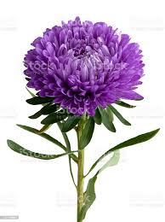](https://www.google.se/imgres?imgurl=https://media.istockphoto.com/photos/chinese-aster-picture-id157196884&imgrefurl=https://www.istockphoto.com/se/foto/chinese-aster-gm157196884-3055554&tbnid=TEp3PVylzSqr-M&vet=12ahUKEwi5zqO72NDyAhVYtyoKHWTOBL4QMyhSegUIARCHAg..i&docid=C9szcL51KNOvDM&w=766&h=1024&q=aster&ved=2ahUKEwi5zqO72NDyAhVYtyoKHWTOBL4QMyhSegUIARCHAg)[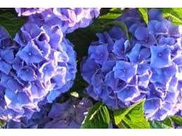](https://www.google.se/imgres?imgurl=https://www.hackvaxteronline.se/media/catalog/product/cache/a0d396ec8beca4aea1cd9245656f474f/C/1/C116.01_a636.jpg&imgrefurl=https://www.hackvaxteronline.se/hortensia-bodensee.html&tbnid=TeQo6GMM-Sn-KM&vet=12ahUKEwiw_cbF2dDyAhUKsioKHcdNDyEQMyguegUIARCeAQ..i&docid=bUHEq-w3v5b7SM&w=400&h=300&q=hortensia&ved=2ahUKEwiw_cbF2dDyAhUKsioKHcdNDyEQMyguegUIARCeAQ)[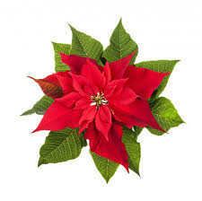](https://www.google.se/imgres?imgurl=https://st.depositphotos.com/1015060/2784/i/600/depositphotos_27840089-stock-photo-christmas-poinsettia-plant-isolated-on.jpg&imgrefurl=https://se.depositphotos.com/stock-photos/julstj%C3%A4rna.html&tbnid=5W7bEmpY9RSgMM&vet=10CHQQMyj6AWoXChMI2Ku84aqi7QIVAAAAAB0AAAAAEAc..i&docid=lQomAOc6_oiruM&w=600&h=595&q=julstj%C3%A4rna&ved=0CHQQMyj6AWoXChMI2Ku84aqi7QIVAAAAAB0AAAAAEAc)[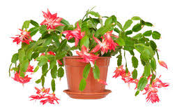](https://www.google.se/imgres?imgurl=https://thumbs.dreamstime.com/t/julkaktus-schlumbergera-i-krukan-som-isoleras-p%C3%A5-vit-backgr-63045627.jpg&imgrefurl=https://se.dreamstime.com/arkivfoto-julkaktus-schlumbergera-i-krukan-som-isoleras-p%C3%A5-vit-backgr-image63045627&tbnid=4WgRKZxzepMXoM&vet=12ahUKEwiJztGSq6LtAhUOgosKHUqVCvcQMygkegUIARCDAg..i&docid=CJCeatLyLXFoeM&w=254&h=160&q=julkaktus&ved=2ahUKEwiJztGSq6LtAhUOgosKHUqVCvcQMygkegUIARCDAg)[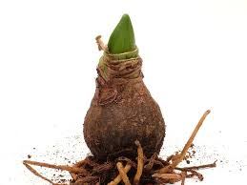](https://www.google.se/imgres?imgurl=https://villalivet.se/wp-content/uploads/2016/11/amaryllis-lok.jpg&imgrefurl=https://villalivet.se/om-tradgard/amaryllis-sa-skoter-du-den/&tbnid=vsliMzSA9WwcFM&vet=10CFEQMyjXAmoXChMI8Nrenqii7QIVAAAAAB0AAAAAEAk..i&docid=vCicoX9TB9dZDM&w=960&h=720&q=amaryllis&ved=0CFEQMyjXAmoXChMI8Nrenqii7QIVAAAAAB0AAAAAEAk)**En bild som visar blomma, växt, bukett
**[](https://www.google.se/url?sa=i&rct=j&q=&esrc=s&source=images&cd=&ved=&url=https://creazilla.com/sv/nodes/4717-jul-varm-dryck-clipart&psig=AOvVaw2QpiT4Y9hKpVu1xAWvB0qh&ust=1575104770142293)[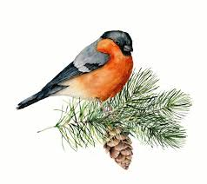](https://www.google.se/imgres?imgurl=https://imengine.lrf.infomaker.io/?uuid%3Ddd9cd4ff-edb2-4b1c-9fa6-61bdb00a004a%26type%3Dpreview%26source%3D%26function%3Dfit%26width%3D630%26height%3D434%26q%3D80%26maxsize%3D630%26name%3Ddomherre3-jpg&imgrefurl=https://www.land.se/djur-natur/fakta-om-domherren/&tbnid=nHo9koK0ygXoWM&vet=10CDgQMyh9ahcKEwi48cusraLtAhUAAAAAHQAAAAAQBA..i&docid=FJDQ5c4kzkHFEM&w=630&h=560&q=domherre&ved=0CDgQMyh9ahcKEwi48cusraLtAhUAAAAAHQAAAAAQBA)



